Secrets at School

Lots of kids share secrets.
Secrets can sometimes be fun.
Planning a birthday surprise and not telling the teacher is exciting.
This is a “don’t spill the beans” kind of secret. It is fun and does not break any school rules. It is OK to share “don’t spill the beans” secrets at school.
Secrets can sometimes be “teasy”.
“I know a secret and you don’t! NAH-Nah-Nah-nah-nah-nah!”
This is a hurt feelings secret. Secrets that hurt feelings break a school rule. It is not OK to share secrets that hurt feelings at school.
Secrets can sometimes exclude other people. These are “leaving out” secrets. Leaving out secrets ignore some people and hurt feelings. It is not OK to share secrets that leave other people out at school.
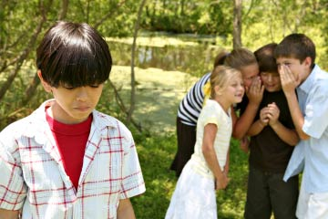

It is important to remember school rules about secrets. Rules keep people safe. The school rules here are Safe Bodies. Safe Work. Safe Feelings. Telling hurt feelings secrets and leaving out secrets is not OK at school. They both break the Safe Feelings rule.
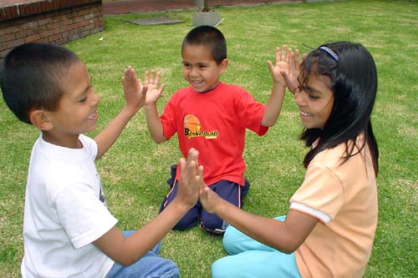

It is important to remember the safe rules at school. It is important to ___________

