What to Do When Something or Someone is Bugging You!
What you can say:
- “What you are doing makes me feel angry.”
- “Please stop doing that”.
- “I feel angry when you ___________”.
- “I’m upset because ______________”.
- “I don’t like it when you __________.”
What you can do:
Take 10 deep breaths. 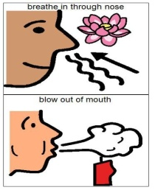
Write about it.
Talk about it when you are calm.

