When Bodies Hurt Others at School

School is sometimes a fun place.
Kids like to build with blocks and magnatiles.
Kids like to read books.
Kids like to paint and draw.

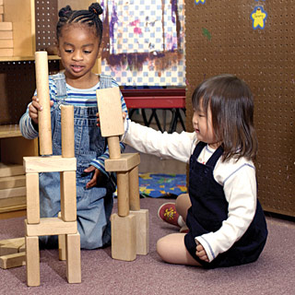

School can also be hard work sometimes.
Sometimes kids have different ideas about how to build a tower.
Sometimes someone else has the book that you want to read.
Sometimes someone else is using the color paint that you really need.

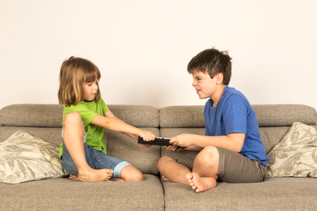

When things like this happen, kids can get really, really mad really, really fast.
When feelings get really big, really fast, sometimes bodies make bad choices.

Mouths sometimes say mean words.
Hand sometimes hit or throw.
Feet sometimes kick.
Teeth sometimes bite.

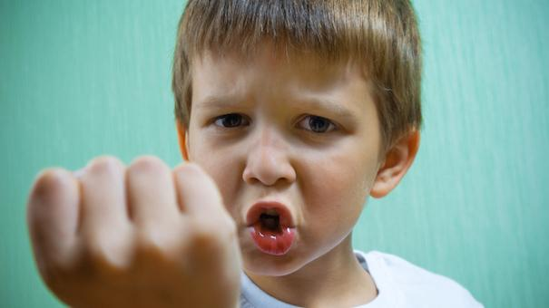

Hurting bodies is never okay at school.
Hurting feelings is never okay at school.

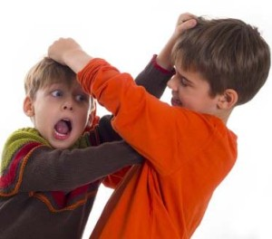

School needs to be safe for everyone.
When hands hit or feet kick or teeth bite someone, teachers need to help.

Teachers need to help children calm down.
Teachers need to help children check in and fix problems.
Teachers need to tell Mommies and Daddies when kids hurt other people’s bodies or feelings.

Teachers and parents need to work together to help children learn to be safe at school.

The End

