Learning to be Friends at School
There are lots of people having fun and learning together at school. Children and grown-ups. Teachers and family members.
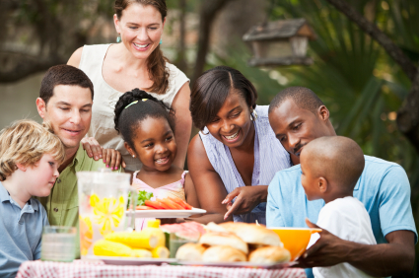
People at school share some wonderful times and learn how to be friends. We read stories, have meetings and sing together.
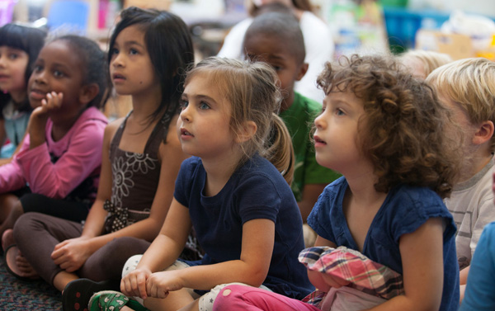
We climb and dig and run together outside.
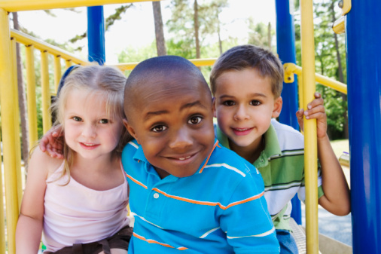

We share snacks and meals together.

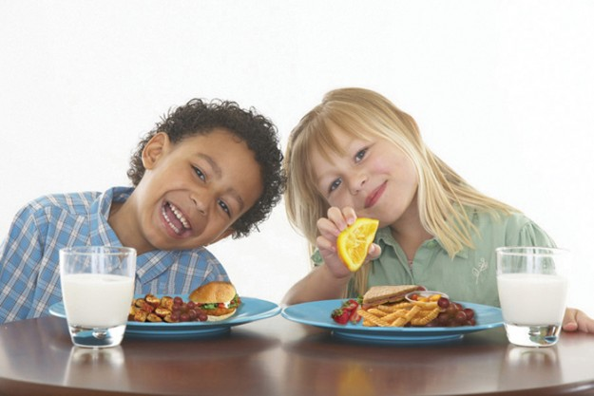
There are important things to remember at school so that everyone is safe and has fun. There are important rules to remember about being a good friend.

School has 4 very important friendship rules in all the classrooms:

Safe feelings,
Safe things,
Safe bodies, and
Safe work.

Everyone follows these rules at school. Children and grown-ups follow these rules at school. Teachers and family members follow these rules at school.
Safe feelings means using words that help people feel good. Safe feelings means trying hard not to yell or make faces at someone when you are upset. (Yelling makes a problem get bigger not better!)
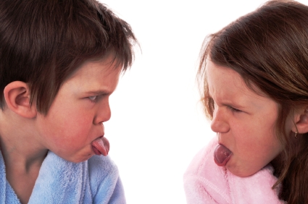

Safe things means that we respect all the materials, toys, books in the school and the things that people bring in from home. Safe things means using them carefully and making sure to be careful. Safe things means fixing things if they break.
Safe bodies means asking before you touch someone else’s body. You can be in charge of your own body, but not anyone else’s! (Not everyone wants to be tickled or touched, even if you want to.)
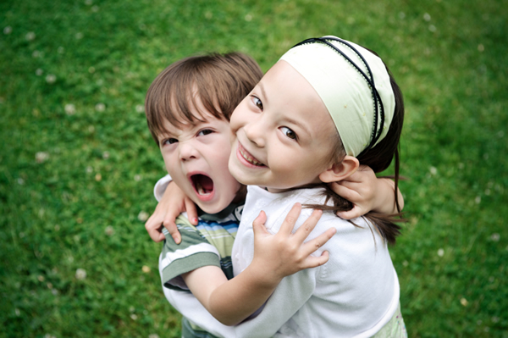
Safe work means we can look at and celebrate everyone’s hard work. We try to never break someone else’s hard work. (Breaking someone’s work will make them sad and mad.)
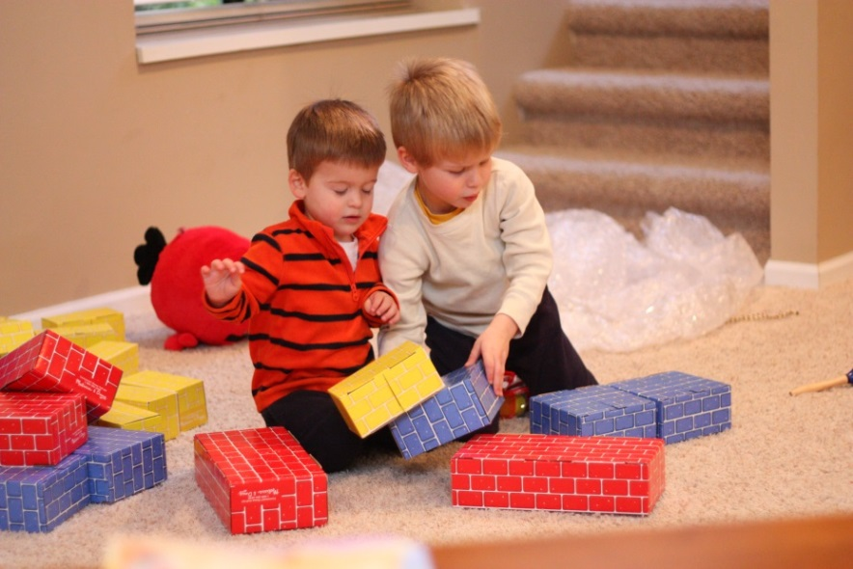
You can make good choices.
You can try to use kind words.
You can respect everyone’s hard work.
You can remember to ask before you touch someone else’s body.
You can learn to be a good friend.

The End

