Drawing and Writing at Home
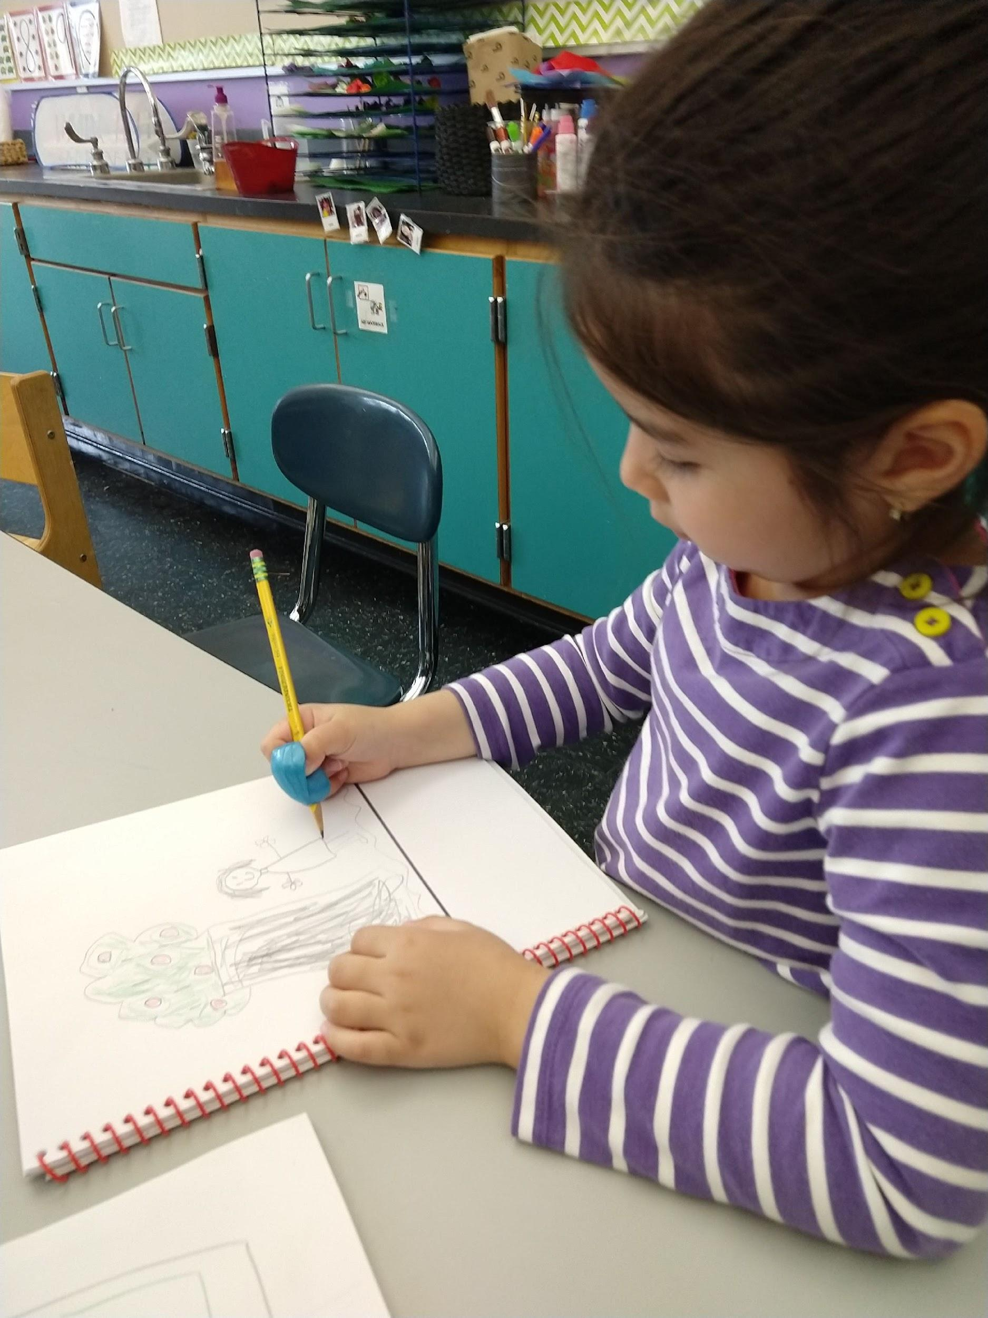

Drawing
- Ask the child to think about a story they would like to tell - “What will you draw (or write) about today?”
- Give the child plenty of time to draw a picture.
- You can watch and listen, or help the child plan how to draw and add details to their drawing.

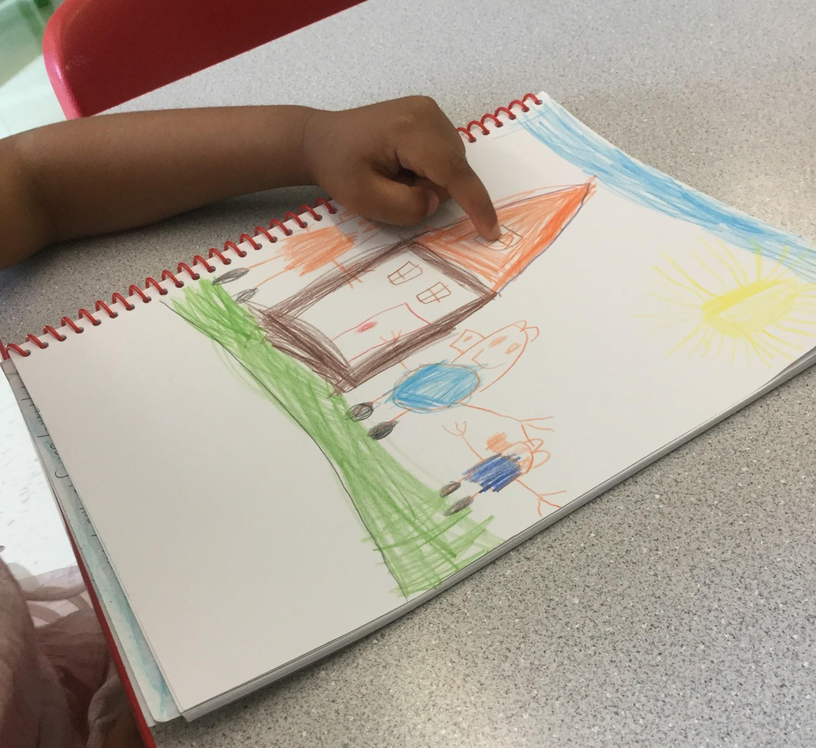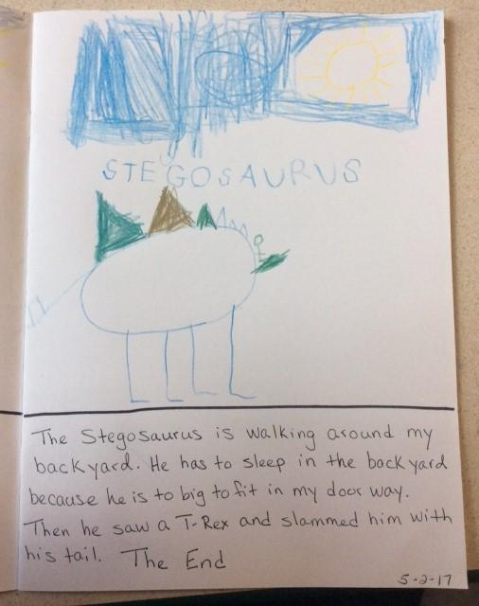

Labeling with Words
- Ask the child, “Tell me about your picture.”
- When the child points and says, “This is a ____ (house),” you can label the child’s picture by writing the word ‘house’ next to the drawing.
- Some children may want to label some of the pictures themselves, using adult help for sounding out and spelling.

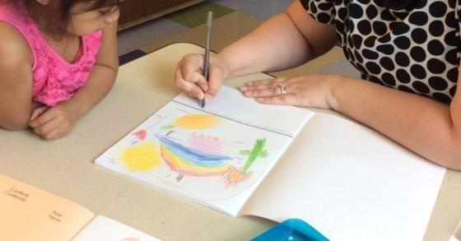

Writing - Dictation
- Ask, “Tell me your story.”
- Use your best print handwriting.
- Writes down what the child says about the picture.
- You can ask the child to say more, or prompt the children for more details by asking questions about the story.

Reading and Revising
- While pointing at each word, read what you have written back to the child and ask - “Do you want to add anything else”?
- If the child says, “Yes,” add what the child has to say.

Finishing
- Write the date on the page.
- Collect these stories in a safe place.

